Task Name:Telecom Customer Churn Prediction using Logistic Regression
Step-1: Install and import libraries:
!pip install scikit-learn
import pandas as pd
import numpy as np
import matplotlib.pyplot as plt
Step-2: Load the dataset and Examine the dataset
print("Shape:", df.shape)
print("\nColumns:")
print(df.columns)
print("\nMissing values:")
print(df.isnull().sum())
print("\nData types:")
print(df.dtypes)
print("\nChurn classes:")
print(df["Churn"].value_counts())
Output:
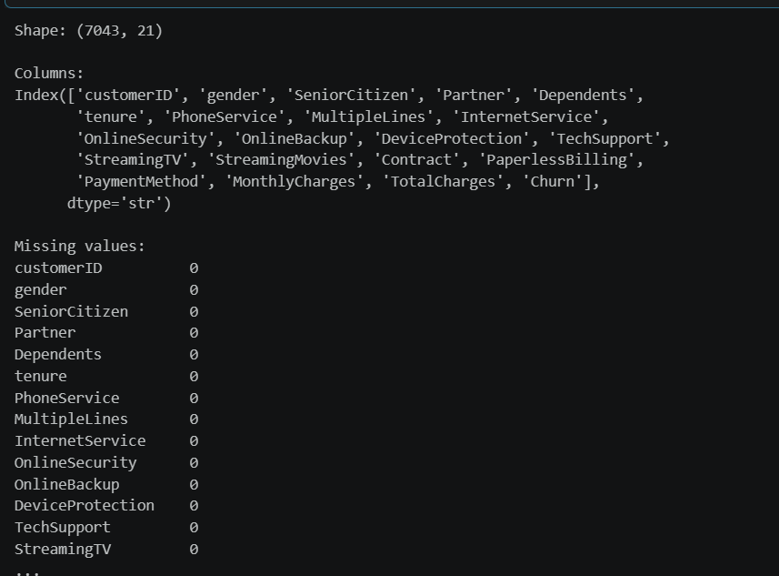
Step 3 — Define X and y
df["TotalCharges"] = pd.to_numeric(df["TotalCharges"],errors="coerce")
df = df.dropna(subset=["TotalCharges"])
X = df[["tenure", "MonthlyCharges", "TotalCharges"]]
y = df["Churn"].map({"No": 0, "Yes": 1})
print("X:")
print(X)

print("\ny:")
print(y)
Output:
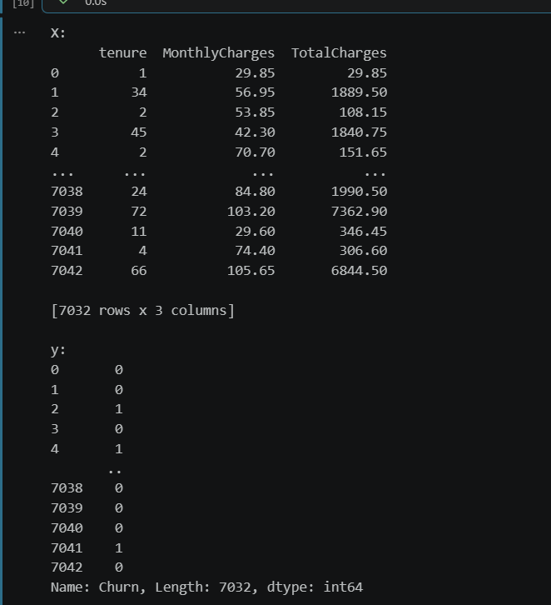
Step 4— Split the dataset
from sklearn.model_selection import train_test_split
X_train, X_test, y_train, y_test = train_test_split( X, y, test_size=0.2, random_state=42, stratify=y)
print("X_train shape:", X_train.shape)
print("X_test shape:", X_test.shape)
print("y_train shape:", y_train.shape)
print("y_test shape:", y_test.shape)
Output:
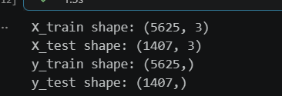
STEP 5 — Create Logistic Regression model
from sklearn.linear_model import LogisticRegression
model = LogisticRegression(max_iter=1000)
model.fit(X_train, y_train)
print("Model trained successfully!")
Output:

STEP 6 — Print intercept and coefficients
print("Intercept (b0):", model.intercept_[0])
print("\nCoefficients:")
for feature, coefficient in zip(X.columns, model.coef_[0]):
print(f"{feature}: {coefficient:.4f}")
Output:
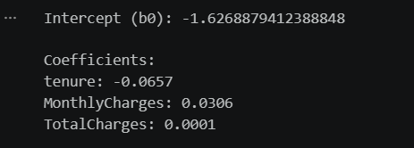
STEP 7— Predict unseen customers
y_pred = model.predict(X_test)
print("Actual values:", y_test.values)
print("Predicted values:", y_pred)
Output:
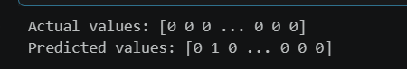
STEP 8 — Predict churn probability
y_probability = model.predict_proba(X_test)[:, 1]
print("Churn probabilities:")
print(y_probability)
Output:
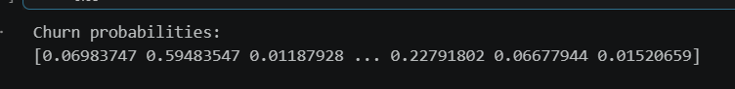
STEP 9 — Predict one new customer
new_customer = pd.DataFrame({ "tenure": [12], "MonthlyCharges": [70], "TotalCharges": [840]})
prediction = model.predict(new_customer)[0]
probability_churn = model.predict_proba(new_customer)[0][1]
print("Tenure:", new_customer["tenure"][0])
print("Monthly Charges:", new_customer["MonthlyCharges"][0])
print("Total Charges:", new_customer["TotalCharges"][0])
print("Probability of Churn:", probability_churn)
print( "Predicted Result:", "Likely to Churn" if prediction == 1 else "Likely to Stay")
Output:
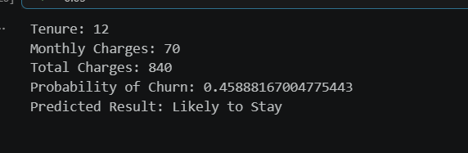
STEP 10 — Accuracy
from sklearn.metrics import accuracy_score
accuracy = accuracy_score(y_test, y_pred)
print("Accuracy:", accuracy)
print("Accuracy (%):", accuracy * 100)
Output:
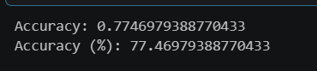
STEP 11 — Confusion Matrix
from sklearn.metrics import confusion_matrix
cm = confusion_matrix(y_test, y_pred)
print("Confusion Matrix:")
print(cm)
Output:
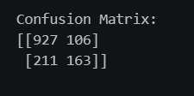
tn, fp, fn, tp = cm.ravel()
print("True Negatives:", tn)
print("False Positives:", fp)
print("False Negatives:", fn)
print("True Positives:", tp)
print("\nCorrectly identified churn customers:", tp)
print( "Non-churn customers misclassified as churn:", fp)
Output:
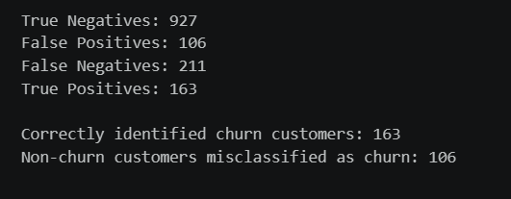
STEP 12 — Confusion Matrix graph
import matplotlib.pyplot as plt
from sklearn.metrics import ConfusionMatrixDisplay
ConfusionMatrixDisplay(confusion_matrix=cm, display_labels=["Stay", "Churn"]).plot()
plt.title("Logistic Regression - Customer Churn Confusion Matrix")
plt.show()
Output:
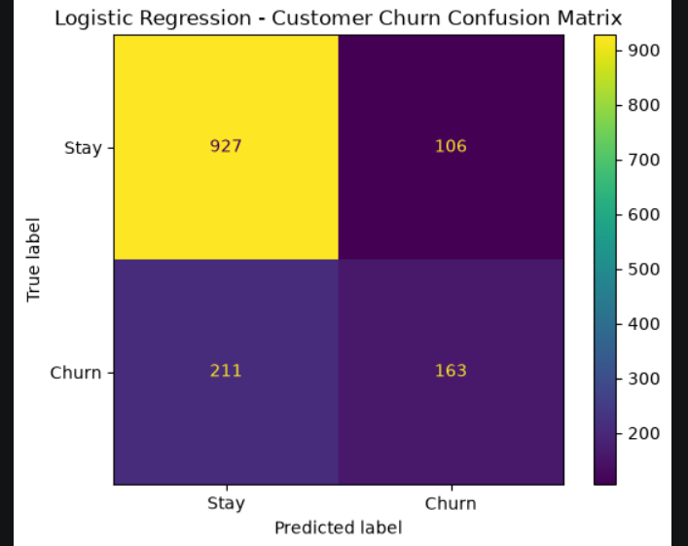
STEP 13— Classification Report
from sklearn.metrics import classification_report
print(classification_report( y_test, y_pred, target_names=["Stay", "Churn"], zero_division=0))
Output: 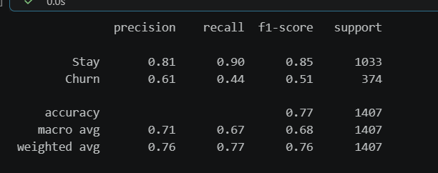

Analysis:
1. How many churn customers were correctly identified?
Answer: 163 churn customers were correctly identified.
2. How many non-churn customers were misclassified?
Answer: 106 non-churn customers were incorrectly classified as churn.
3. Is it better to wrongly flag a loyal customer as churn or miss a customer who is actually going to leave?
Answer: It is better to wrongly flag a loyal customer as churn because missing a customer who is actually going to leave can cause customer and revenue loss.
4. Suggest one improvement to make the prediction more reliable.
Answer: Include more relevant customer features such as Contract, InternetService, PaymentMethod, and TechSupport to improve the prediction.

